Python MLOps Project

Understand Project Structure
File | Purpose
data_ingestion.py | load dataset
preprocessing.py | preprocess & split data
train.py | preview/check training data
model_training.py | actual model training

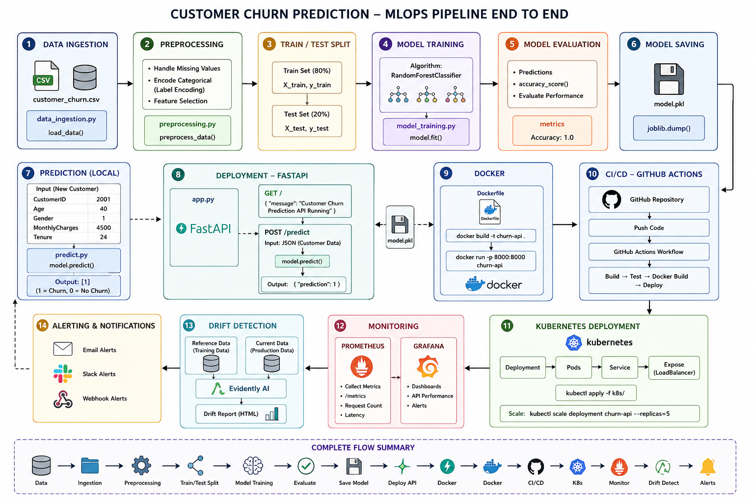

py -m pip install fastapi uvicorn pandas scikit-learn joblib

1. data_ingestion.py

Purpose
Used to:
- load dataset into Python
- start ML pipeline

Code Flow
import pandas as pd
Imports pandas library for:
- reading CSV
- handling tabular data

def load_data(path):
Creates function:
- load_data()
Accepts:
- dataset path

df = pd.read_csv(path)
Reads CSV file into:
- pandas DataFrame

return df
Returns dataset.

Real ML Flow
CSV Dataset
↓
Data Ingestion

2. preprocessing.py

Purpose
Used for:
- encoding categorical values
- splitting dataset into training/testing

Important Concepts

Label Encoding
Converts:
Original | Encoded
Male | 1
Female | 0
Yes | 1
No | 0
Because ML models understand:
- numbers
- not text

Features and Target
X = df.drop("Churn", axis=1)
Creates:
- input features

y = df["Churn"]
Creates:
- target output

Train-Test Split
train_test_split(
X,
y,
test_size=0.2,
random_state=42
)

Meaning
Dataset | Purpose
X_train | training inputs
X_test | testing inputs
y_train | training answers
y_test | testing answers

test_size=0.2
20% dataset used for:
- testing
80% used for:
- training

random_state=42
Ensures:
- same random split every time

X_train (Training Features)
Index | CustomerID | Age | Gender | MonthlyCharges | Tenure
13 | 1014 | 28 | 0 | 2700 | 11
5 | 1006 | 29 | 0 | 2800 | 10
8 | 1009 | 27 | 1 | 3100 | 14
2 | 1003 | 45 | 1 | 5400 | 36
1 | 1002 | 30 | 0 | 3200 | 24

y_train (Training Target)
Index | Churn
13 | 1
5 | 1
8 | 0
2 | 0
1 | 1

X_test (Testing Features)
Index | CustomerID | Age | Gender | MonthlyCharges | Tenure
9 | 1010 | 33 | 0 | 3900 | 22
11 | 1012 | 31 | 0 | 3400 | 16
0 | 1001 | 25 | 1 | 2500 | 12

y_test (Testing Target)
Index | Churn
9 | 1
11 | 1
0 | 0

Meaning
Dataset | Purpose
X_train | Input data used for model learning
y_train | Correct answers used during training
X_test | New unseen data used for testing
y_test | Actual answers used for accuracy evaluation

Churn Meaning
Churn means:
Customer leaving the company/service
Example:
- cancelling subscription
- leaving telecom provider
- stopping product usage
Example pattern:
MonthlyCharges | Tenure | Churn
High | Long | No
Low | Very Short | Yes
Model tries to learn:
"What kind of customers usually leave?"

Value | Meaning
1 | Customer churned
0 | Customer did not churn

How ML Prediction Works Internally
The model mathematically learns:
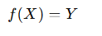
Where:
Symbol | Meaning
X | Customer features
Y | Churn prediction

Real Industry Usage
This exact concept is used in:
- telecom companies
- Netflix
- banks
- insurance
- SaaS platforms
to identify customers likely to leave.

Gender Encoding
Value | Meaning
1 | Male
0 | Female

Important Understanding
Training dataset actually contains:
15−3=12
So:
Dataset | Rows
Training | 12
Testing | 3

Calculation
15×0.2=3
So:
- 3 rows → testing
- 12 rows → training

How Rows Are Chosen?
By default:
Randomly

Example
Suppose dataset rows are:
0,1,2,3,4,5,6,7,8,9,10,11,12,13,14
Python randomly shuffles them internally.
Example shuffled order:
13,5,8,2,1,14,4,7,10,6,12,3,9,11,0

Then Split Happens
First 12 rows:
Training Data
Last 3 rows:
Testing Data

3. train.py

Purpose
Used for:
- checking preprocessing
- inspecting training/testing data
This is:
- learning/debugging file
NOT actual production training pipeline.

Flow
Load Dataset
↓
Preprocess Dataset
↓
Print Training Data

Important Output

X_train
Contains:
- customer features

y_train
Contains:
- correct churn answers

4. model_training.py

Purpose
Main ML training pipeline.
Responsible for:
- model creation
- training
- prediction
- evaluation
- saving model

RandomForestClassifier
RandomForestClassifier()
Inbuilt ML algorithm from:
- scikit-learn
Uses:
- multiple decision trees
- voting mechanism

n_estimators=200
Means:
200 decision trees
inside forest.
More trees:
- usually better accuracy
- but slower training.

What Is Random Forest?
Random Forest is a:
Supervised Machine Learning Classification Algorithm
Used for:
- Yes/No prediction
- classification problems
Example:
- churn prediction
- fraud detection
- disease prediction

Why Called “Random Forest”?
Because it creates:
many decision trees
and combines their decisions.
Suppose:
- 200 teachers solve same question.
If:
- most teachers say YES
final answer becomes:
YES
Same idea in Random Forest.

Example
Suppose 5 trees predict:
Tree | Prediction
Tree 1 | Yes
Tree 2 | Yes
Tree 3 | No
Tree 4 | Yes
Tree 5 | No
Majority:
Yes
So final output:
Yes

Why Random Forest Popular?
Because:
- easy to use
- good accuracy
- handles large data
- reduces overfitting
Very commonly used in industry.
Model Trained
f(x)=RandomForestClassifier(X)

Predictions Generated
model.predict(X_test)

Accuracy Measured
Accuracy formula:

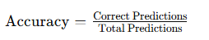

Why Accuracy = 1.0 ?
Because:
- Dataset is very small
- Very clean data
- Easy pattern recognition

In real-world projects:
0.80 – 0.95 accuracy
is more realistic.

fit()
model.fit(X_train, y_train)

Meaning
Model learns patterns from:
- historical training data

predict()
model.predict(X_test)

Meaning
Predicts outcomes for:
- unseen testing data

accuracy_score()
accuracy_score(y_test, predictions)
Compares:
- actual values
- predicted values
Calculates:
- model accuracy

joblib.dump()
joblib.dump(model, "model.pkl")
Saves trained model into:
- model.pkl
Used later for:
- API prediction
- deployment

5. predict.py

Purpose
Used for:
- inference/prediction
Simulates:
- real production prediction

joblib.load()
model = joblib.load("model.pkl")
Loads saved trained model.

Dummy Input
sample_data = pd.DataFrame({...})
Creates:
- new unseen customer data

Prediction
prediction = model.predict(sample_data)
Generates:
- churn prediction

Output Meaning
Value | Meaning
1 | Customer may churn
0 | Customer may not churn

6. app.py

Purpose
Deploy ML model as:
- REST API
Using:
- FastAPI

FastAPI
app = FastAPI()
Creates:
- API application

Root Endpoint
@app.get("/")
Health-check API.

Prediction Endpoint
@app.post("/predict")
Creates:
- prediction API

Input JSON
{
"CustomerID": 3001,
"Age": 35,
"Gender": 1,
"MonthlyCharges": 5000,
"Tenure": 24
}

{
"CustomerID": 4001,
"Age": 22,
"Gender": 0,
"MonthlyCharges": 2500,
"Tenure": 2
}

Prediction Flow
Client Request
↓
FastAPI
↓
Load Model
↓
Prediction
↓
JSON Response

Run API
uvicorn app:app --reload

Swagger UI
http://127.0.0.1:8000/docs
Used for:
- API testing
- API documentation

7. Docker

Purpose
Containerize application.

Docker Build
docker build -t churn-api .
Creates:
- Docker image

Docker Run
docker run -p 8000:8000 churn-api
Runs:
- containerized API

Why Docker?
Solves:
- dependency issues
- environment mismatch
- portability problems

docker build -t churn-api .
docker login
docker tag churn-api shekharglobal/churn-api:v1
docker push shekharglobal/churn-api:v1
docker pull shekharglobal/churn-api:v1
docker run -p 8000:8000 shekharglobal/churn-api:v1

8. CI/CD

Purpose
Automate:
- build
- testing
- deployment

GitHub Actions Flow
Code Push
↓
GitHub Actions
↓
Automated Pipeline

Workflow File
.github/workflows/main.yml

git init

git add

git remote add origin https://github.com/ShekharGlobal/MLOps.git

git commit -m "Initial MLOps project setup"

git push -u origin master

next onwards

git add .
git commit -m "Added requirements file"
git push.

9. Prometheus

Purpose
Monitoring API metrics.
py -m pip install prometheus-fastapi-instrumentator

Metrics Endpoint
/metrics
Provides:
- request count
- latency
- performance metrics

What This Adds
This line:
Instrumentator().instrument(app).expose(app)
automatically tracks:
Metric | Example
API requests | total requests
Response time | latency
Errors | 500 errors
Request size | payload size

Run FastAPI Again
py -m uvicorn app:app --reload

Open Metrics Endpoint
Open browser:
http://127.0.0.1:8000/metrics

You Will See
http_requests_total
http_request_duration_seconds
These are Prometheus metrics.

Why Monitoring Matters
Without monitoring:
API crashes silently
Slow responses unnoticed
Prediction failures hidden
With monitoring:
Track API health
Detect failures
Measure performance
Monitor ML behavior

10. Grafana

Purpose
Visualization dashboard.
Used for:
- charts
- monitoring dashboards
- production observability

Prometheus collects metrics.
Grafana VISUALIZES metrics beautifully.
D:/ML/prometheus.yml

docker pull grafana/grafana
docker run -d --name grafana -p 3000:3000 grafana/grafana
docker run -d --name prometheus -p 9090:9090 -v D:/ML/prometheus.yml:/etc/prometheus/prometheus.yml prom/Prometheus
http://127.0.0.1:9090-- prometheus
http://localhost:3000- Grafna

Default Login
Username | Password
admin | admin

After Login
Go to:
Connections
↓
Data Sources
↓
Add Data Source
Choose:
Prometheus
URL:
http://host.docker.internal:9090
Then:
Save & Test
Expected:
Data source is working
Now your monitoring stack becomes:
FastAPI
↓
Prometheus
↓
Grafana Dashboard
This is real production observability

Add First Query
Use:
http_requests_total
Click:
Run Query

Generate API Traffic
Open:
http://127.0.0.1:8000/docs
Run /predict multiple times.
Now dashboard graphs will start moving

What You Are Monitoring
Metric | Meaning
http_requests_total | API traffic
request_duration | API speed
error_count | failures
latency | response time

11. Drift Detection

Purpose
Detect:
- data drift
- model behavior changes
Using:
- Evidently AI
pip install evidently==0.4.19

Why Drift Detection Matters
Your ML model is trained on OLD data:
customer_churn.csv
But in production:
customer behavior changes over time
Example:
Year | Customer Behavior
2024 | low charges → churn
2026 | high charges → churn
Your old model slowly becomes inaccurate.
This is called:

Model Drift

Real Industry Problem
Model accuracy in training = 95%
Model accuracy in production after 6 months = 60%
because:
- users changed
- business changed
- market changed
- patterns changed

Types of Drift

1. Data Drift
Input data distribution changes.
Example:
Training Data | Production Data
Avg Age = 35 | Avg Age = 60

2. Concept Drift
Relationship changes.
Example:
Old:
Low tenure → churn
New:
High charges → churn
Model logic itself becomes outdated.

Real Drift Architecture
Production API
↓
Prediction Logs
↓
Drift Detection
↓
Alert
↓
Retraining
Install Drift Detection Library
py -m pip install evidently

What Is Evidently?
Evidently AI is a popular MLOps tool used for:
- data drift detection
- model monitoring
- ML dashboards
- ML reports
Create Drift Detection Script
drift_detection.py

What This Does
We intentionally create drift:
current_data["Age"] = current_data["Age"] + 20
Meaning:
Training Avg Age | Production Avg Age
35 | 55
This simulates real production drift.

STEP 3 → Run Drift Detection
Run:
py drift_detection.py
Expected:
Drift report generated successfully!

STEP 4 → Open Report
Open generated file:
drift_report.html

What Will See
Evidently will show:
Feature | Drift Status
Age | Drift Detected
Tenure | No Drift
Charges | No Drift

Drift Flow
Reference Data
↓
Current Data
↓
Drift Detection
↓
HTML Report

12. Kubernetes

Purpose
Container orchestration and scaling.

Why Kubernetes?
Currently you run:
1 FastAPI container
Problem:
What if:
Situation | Problem
10,000 users | server overload
container crash | app down
high traffic | slow predictions
Need:
- auto scaling
- self healing
- load balancing
That is exactly what Kubernetes does.

Kubernetes Architecture
Users
↓
Load Balancer
↓
Kubernetes Service
↓
Multiple FastAPI Pods

Important Kubernetes Terms
Term | Meaning
Pod | running container
Deployment | manages pods
Service | exposes app
Replica | number of copies
Scaling | increase/decrease pods

Real Production Example
Without Kubernetes:
1 container only
With Kubernetes:
5 FastAPI replicas
If one crashes:
Kubernetes auto recreates it

Kubernetes Scaling Concept
Traffic ↑
↓
Kubernetes creates more pods
Traffic decreases:
Kubernetes removes extra pods

Key Concepts
Component | Purpose
Pod | running container
Deployment | manages pods
Service | exposes application
Replica | multiple pod copies

Scaling Example
kubectl scale deployment churn-api-deployment --replicas=5
Used for:
- horizontal scaling
kubectl apply -f deployment.yaml

kubectl apply -f service.yaml

kubectl get pods

http://localhost:30007/docs
astAPI ML app is now running INSIDE Kubernetes.

Kubernetes Scaling Demo
Now increase replicas.
Edit:
replicas: 5
Then apply again:
kubectl apply -f deployment.yaml
kubectl get pods
You should now see:
5 Running Pods

Complete MLOps Architecture
Dataset
↓
Data Ingestion
↓
Preprocessing
↓
Model Training
↓
Save Model
↓
FastAPI Deployment
↓
Docker
↓
CI/CD
↓
Monitoring
↓
Drift Detection
↓
Kubernetes Scaling

